Practical Demonstration Day

Structural Concrete Alliance CPD Practical Event

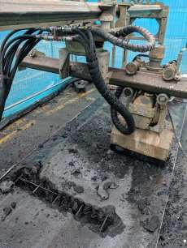
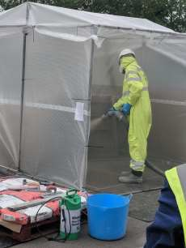
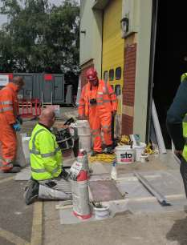
This event is free of charge and approved by the Construction CPD Certification Service

Thursday 8th September 2022

Resapol, Unit D4, Moss Industrial Estate,
St. Helens Road, Leigh, Lancashire, WN7 3PT

www.structuralconcretealliance.com

Booking Form
Practical Demonstration Day

PLEASE NOTE: If you are a CPA, CRA or SCA member and wish to attend all delegates space will be charged at £50 + VAT per person*. If you are not a member of the CPA, CRA or SCA this event is free of charge.

To book your place at the practical demonstration day please complete the details below and return by email to:
bookings@agmhouse.com

PLEASE COMPLETE THIS SECTION: (please print)

Please reserve delegate places for the following individuals:
Delegate Name | Email Address | Dietary Requirements
1.
2.
3.
4.
5.

Company Name
Contact Name
Email
Address
Telephone

- I am a CPA, CRA or SCA member (£50 +VAT per delegate)
- I am a non-member (free of charge)
- I require a CPD-accredited certificate of attendance

PLEASE ENSURE THIS REFERENCE BOX IS COMPLETED TO ENABLE US TO ASCERTAIN HOW YOU
RECEIVED THE BOOKING FORM, e.g Name/Company that sent you the information.

I understand that full PPE* is required for all delegates and as such confirm that I will supply and wear my own PPE at all times during the event. If you do not have access to these please ensure you contact the Alliance Office prior to the event. We regret any delegate not complying to this will be refused entry to the site. *Safety Boots, High Vis Vest and Hard Hat.

Signature Date

Cancellation Policy

Cancellation Policy: Cancellations must be received in writing (via email) in advance of the event.
The following cancellation charges apply: a. 6-4 weeks notice: 50% refund b. 4-0 weeks notice: No refund c. Failure to attend: No refund
Payment: Payment must be received, in full, prior the event. If full and cleared payment has not been received you will be asked to make payment on the day of the event, the on-site card machine will incur a 3.4% surcharge (access to the event may be refused at the organisers discretion for non-payment).

General Course Information

- The Alliance shall endeavour to ensure that the published programme is provided. However, the Association reserves the right to alter published timetables.
- The events shown are those currently offered by the Alliance and the contents remain the property of the Alliance at all times.
- Accommodation is not included with any of the Alliance events. Candidates must make their own arrangements
- Refreshments: All courses include refreshments, candidates must notify the Alliance offices of any dietary requirements prior to the event commencing
- Transportation is not included with any of the Alliance courses. Candidates must make their own arrangements
- Special requirements: delegates are requested to provide notice of any special requirements they may have.
- The Alliance reserves the right to cancel an event at their discretion. The Alliance will endeavour to give 2
working weeks’ notice of cancellations.
The Association’s liability shall be limited to a refund of any booking fees paid.

Signed: Print Name:

Date:

Company Name:

Data Protection Declaration

The Structural Concrete Alliance (Alliance) fully complies with existing data protection legislation and in accordance with this will hold the data contained in this form for administrative purposes. By completing this form, you give your consent that the information you have provided will be held securely within the Alliance records and used to process your registration.

We’d love to keep you up to date with our interesting events, news, research, and courses that are going on at
The Alliance. If you’d like to continue to keep receiving these, please tick the box below.

I wish to continue to receive communication from The Structural Concrete Alliance

